CSS  
  
  
**Q1:-**  What are the benefits of using CSS?  
 **Ans. :-** Cascading Style Sheets (CSS) offer several benefits in web development by providing a way to control the layout, presentation, and styling of HTML documents. Without CSS, styling is often embedded within HTML using attributes like **<font>** and **<style>**. With CSS, you can separate the styling from the HTML content, making the code cleaner and more maintainable.  
  
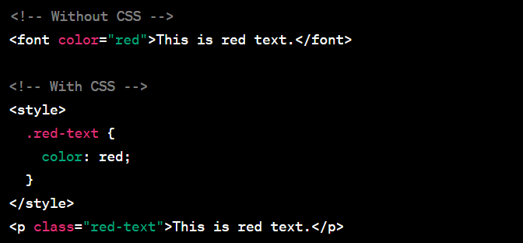

**Q2:-** What are the disadvantages of CSS?  
  
ANS:- While CSS has many advantages, there are also some challenges and disadvantages associated with its use in web development. Different web browsers may interpret CSS rules differently, leading to inconsistencies in the appearance of a website. Developers often need to add browser-specific prefixes or workarounds to ensure cross-browser compatibility.  
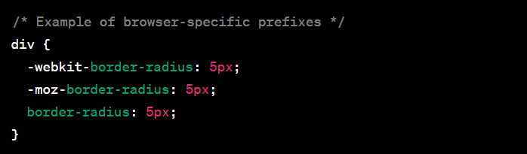

### Q3:- What is the difference between CSS2 and CSS3? ANS:- CSS (Cascading Style Sheets) is a style sheet language used for describing the presentation of a document written in HTML or XML. CSS evolves over time, and different versions introduce new features and improvements. The main difference between CSS2 and CSS3 lies in the set of features and capabilities each version offers.

**Q4:-** Name a few CSS style components  
ANS:-1. **Color:**

* The **color** property is used to set the text color of an element. It can accept color names, hexadecimal codes, RGB values, or HSL values.  
    
  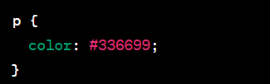

**2. Font:**

* + Font-related properties like **font-family**, **font-size**, **font-weight**, and **font-style** control the typography of text within an element.

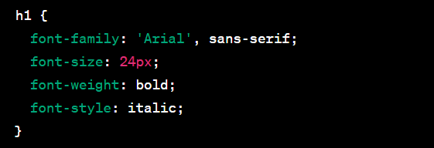  
  
 **3 Background:**

* The **background** property is used to set background-related styles, including **background-color**, **background-image**, **background-position**, and **background-repeat**.

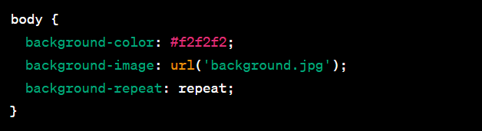  
  
  
  
  
  
  
  
  
  
  
  
  
4. **Box Model:**The box model components include properties like **width**, **height**, **margin**, **padding**, and **border**,which control the size and spacing of elemets.  
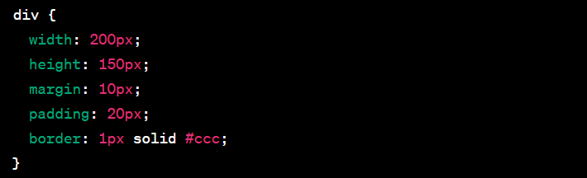

**Q5:-** What do you understand by CSS opacity?  
ANS:- CSS **opacity** is a property that controls the transparency of an element, affecting the visibility of both the element and its content. The **opacity** property accepts values between 0 and 1, where 0 indicates complete transparency (invisible), and 1 indicates full opacity (completely visible). Values between 0 and 1 represent varying levels of translucency.  
  
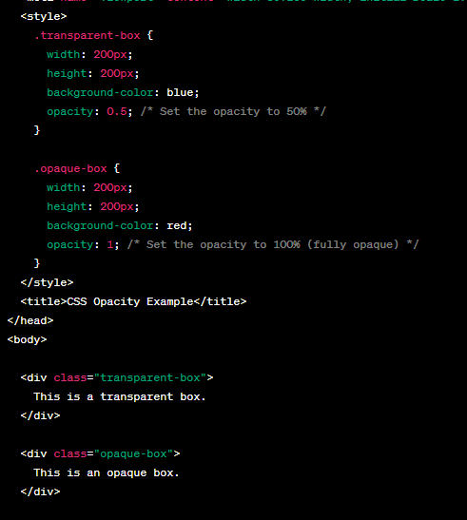

**Q6:-** How can the background color of an element be changed?  
ANS:- The background color of an HTML element can be changed using the CSS **background-color** property. This property sets the background color of an element, and you can specify the color using various methods, including color names, hexadecimal codes, RGB values, or HSL values. Here are a few examples:  
  
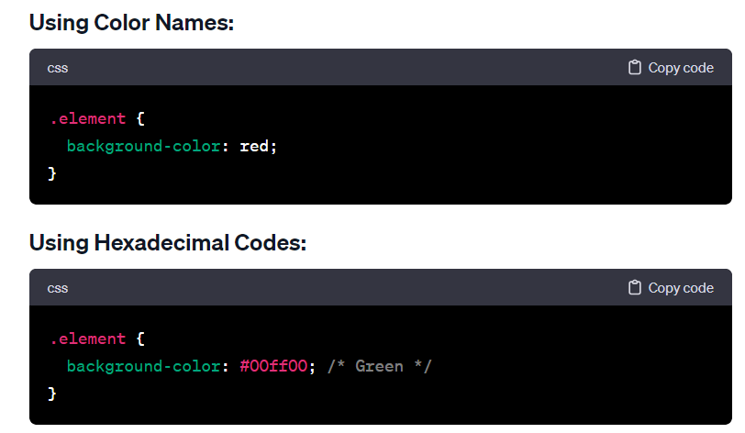  
  
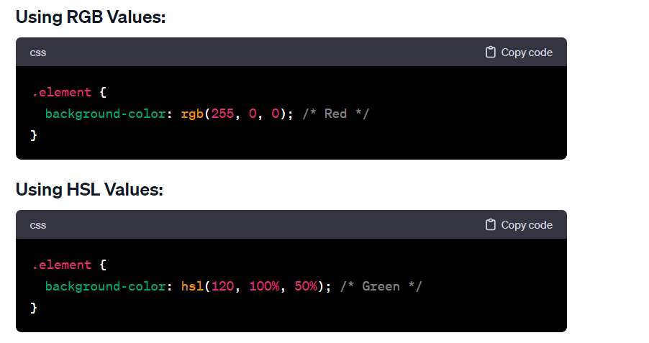

**Q7:-** • How can image repetition of the backup be controlled?  
ANS:- If you're referring to controlling the repetition of a background image in CSS, you can use the **background-repeat** property. This property allows you to specify whether and how a background image should be repeated both horizontally and vertically. The **background-repeat** property accepts the following values:

* **repeat**: The default value. The background image is repeated both horizontally and vertically.
* **repeat-x**: The background image is repeated horizontally.
* **repeat-y**: The background image is repeated vertically.
* **no-repeat**: The background image is not repeated.

**Q8:-** What is the use of the background-position property? **ANS:-** The **background-position** property in CSS is used to specify the starting position of a background image within its containing element. It determines where the top-left corner of the background image should be placed, and it accepts various values to control its positioning. The property can take one or two values, representing the horizontal and vertical positions, respectively.

* 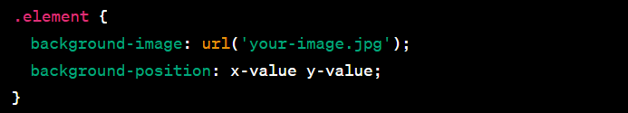  
    
    
  **x-value**: Can be a length value (such as pixels or percentages) or a keyword (e.g., **left**, **center**, **right**).
* **y-value**: Similar to **x-value**, it can be a length value, a percentage, or a keyword (**top**, **center**, **bottom**).

**Q9:-** Which property controls the image scroll in the background?  
ANS:- The property that controls the background image scroll in web development is usually the **background-attachment** property in CSS. The **background-attachment** property determines whether a background image scrolls with the rest of the page or remains fixed in place.

There are three possible values for the **background-attachment** property:

1. **scroll**: This is the default value. The background image will scroll along with the content of the web page.  
     
   2. **fixed**: The background image will remain fixed in place while the content of the web page scrolls. This creates a parallax effect.  
     
   3. **local**: The background image will scroll with the element's contents. This is not supported in all browsers.

**Q10:-** Why should background and color be used as separate properties?  
ANS:- In CSS, the **background** property is a shorthand property that combines several individual background-related properties into one. These properties include **background-color**, **background-image**, **background-repeat**, **background-position**, **background-size**, **background-attachment**, and **background-origin**. While it's convenient to use the **background** shorthand for simplicity and brevity, there are situations where using **background-color** and **background-image** as separate properties can be beneficial. Here are some reasons:

1. **Clarity and Readability:** Separating **background-color** and **background-image** makes the code more readable and easier to understand, especially for those who may be reviewing or maintaining the code. It provides a clear distinction between the color and image aspects of the background.  
     
   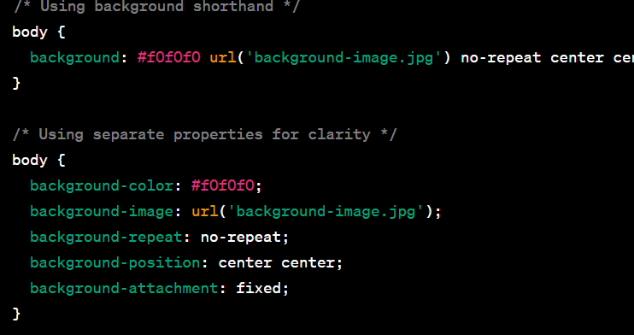  
     
   **2. Ease of Modification:** If you want to change only the color or only the image, using separate properties allows for easy modification without affecting the other aspects of the background.  
     
   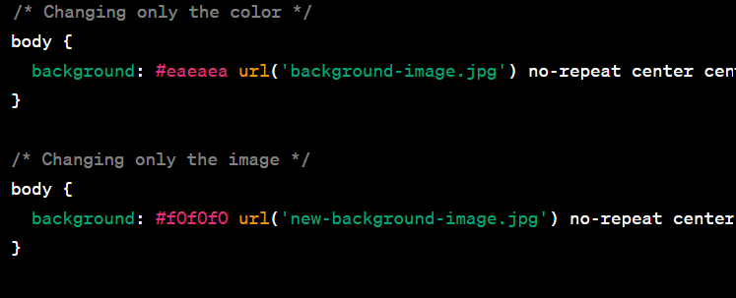  
     
   **3. Fallbacks and Graceful Degradation:** When dealing with older browsers or situations where the image may not load, having a separate **background-color** provides a fallback. This ensures that even if the image fails to load, there is still a background color visible.
2. Q11:- • How to center block elements using CSS1?  
   ANS:- CSS1 (Cascading Style Sheets, Level 1) is the initial version of the CSS specification, and it was first introduced in 1996. CSS1 has limited capabilities compared to the later versions of CSS. Centering block elements, especially vertically, can be a bit challenging with CSS1 alone. However, here's a basic example of horizontally centering a block-level element using CSS1:  
     
   1. The **body** element has **text-align: center;**. This will horizontally center all inline and inline-block elements within the **body**.
3. The block element with the class **.center-block** has **display: inline-block;**. This makes the block element behave like an inline-block element, allowing it to be horizontally centered within the **body**.  
     
   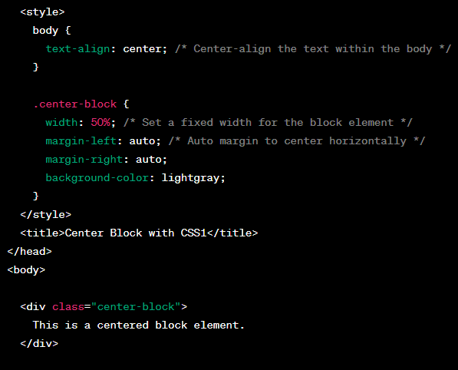

Q12:- How to maintain the CSS specifications?  
ANS:- Maintaining CSS specifications involves staying informed about updates, following best practices, and adapting to changes in the web development landscape. Here are some general guidelines to help you maintain CSS specifications effectively:

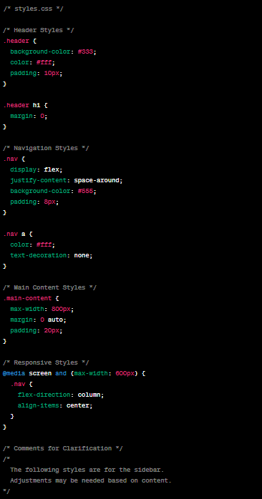

Q13:- What are the ways to integrate CSS as a web page?  
ANS:- There are several ways to integrate CSS into a web page. The choice of method depends on your specific needs and the complexity of your project. Here are the common ways to integrate CSS into a web page:

1. **Inline Styles:**
   * Inline styles involve placing the CSS directly within the HTML document using the **style** attribute. This method is suitable for applying styles to a specific elemen
2. **Internal Styles (Embedded Styles):**

* Internal styles are defined within the HTML document using the **<style>** element in the document's . **<head>** section. This method allows you to apply styles to multiple elements within the same HTML document.  
    
  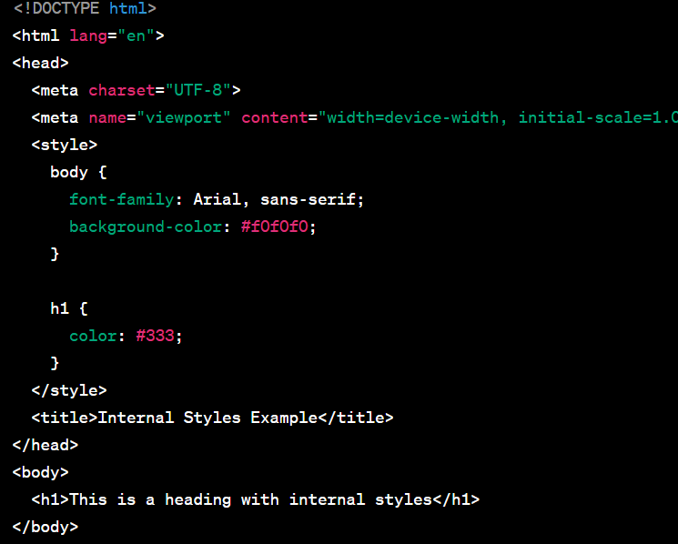

1. **External Styles (Linked Stylesheets):**

* External styles involve linking an external CSS file to the HTML document using the **<link>** element in the **<head>** section. This method is recommended for larger projects as it allows for better organization and reuse of styles across multiple pages.

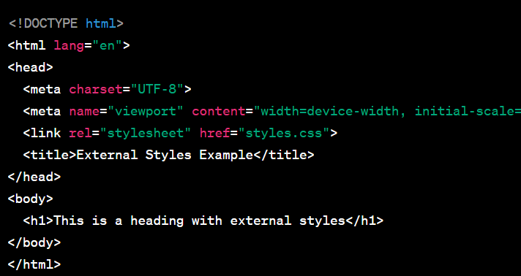  
  
  
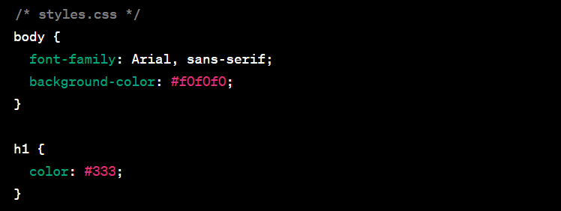

Q14:- What is embedded style sheets?   
ANS:- Embedded styles, also known as internal styles or embedded style sheets, refer to the practice of including CSS styles directly within the HTML document using the **<style>** element. This method allows you to define styles that are specific to a particular HTML document and are contained within the document itself.

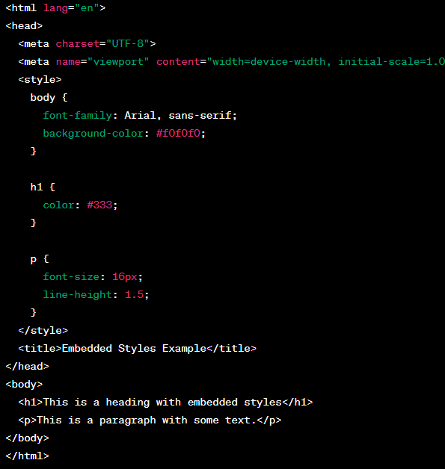

* Q15:- What are the external style sheets?  
  ANS:- External stylesheets refer to separate CSS files that are linked to HTML documents using the **<link>** element. This approach allows you to define styles in a separate file, promoting better organization, reusability, and separation of concerns in your web development projects.  
    
  The CSS rules are defined in a separate file named **styles.css**.
* The HTML document includes a **<link>** element in the **<head>** section, specifying the **href** attribute with the path to the external CSS file (**styles.css**).

Q16:- What are the advantages and disadvantages of using external style sheets?  
ANS:- Using external stylesheets in web development has several advantages and a few potential disadvantages. Here's an overview of both:

**Advantages:**

1. **Modularity and Reusability:**
   * **Advantage:** External stylesheets promote modularity by allowing you to reuse the same stylesheet across multiple HTML pages. This is beneficial for maintaining a consistent look and feel throughout a website.
2. **Separation of Concerns:**
   * **Advantage:** External stylesheets contribute to the separation of concerns in web development. HTML focuses on content structure, while CSS handles the presentation and styling. This separation makes the codebase easier to maintain and understand.
3. **Easier Maintenance:**
   * **Advantage:** Changes to the styling can be made in a single external stylesheet, and those changes automatically apply to all linked HTML documents. This simplifies maintenance and updates.
4. **Caching and Performance:**
   * **Advantage:** External stylesheets are often cached by browsers, improving performance for returning visitors. Subsequent page loads can benefit from the cached stylesheet without re-downloading it.
5. **Consistent Styling:**
   * **Advantage:** External stylesheets ensure a consistent styling approach across all pages that link to the same stylesheet. This is crucial for branding and user experience.
6. **Ease of Collaboration:**
   * **Advantage:** External stylesheets make it easier for multiple developers or teams to collaborate on a project. The styling can be maintained separately from the HTML, facilitating teamwork.  
       
     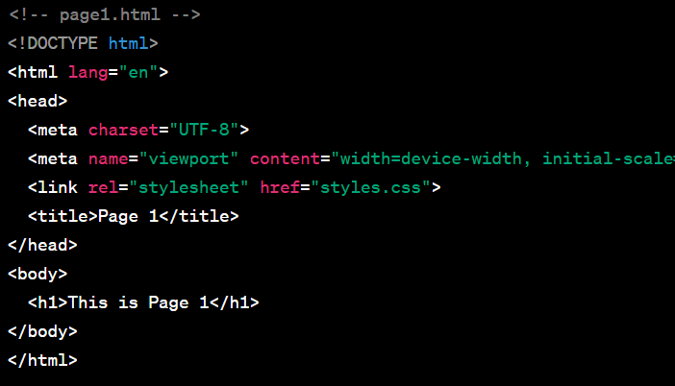  
       
       
     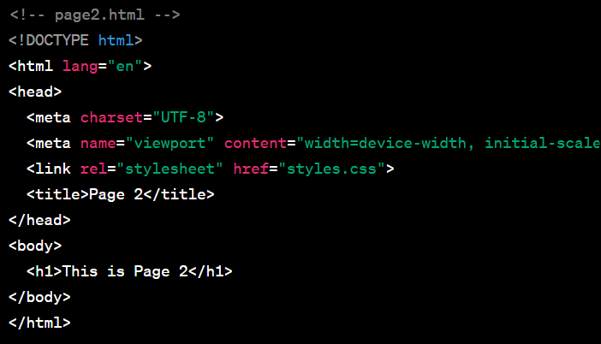

**Disadvantages:**

1. **Additional HTTP Request:**
   * **Disadvantage:** Each external stylesheet results in an additional HTTP request. While modern browsers are optimized for handling multiple requests, minimizing the number of requests can still be a consideration for performance.
2. **Dependency on External Resources:**
   * **Disadvantage:** The rendering of the page depends on the availability and loading of the external stylesheet. If the stylesheet fails to load or there is a network issue, it can affect the visual presentation of the page.
3. **Not Suitable for Offline Use:**
   * **Disadvantage:** If a user accesses a page while offline or in situations with limited connectivity, external stylesheets may not be available, leading to unstyled content.
4. **Potential for Overreliance on Global Styles:**
   * **Disadvantage:** When using a global stylesheet for an entire website, there's a risk of overreliance on global styles that may not be suitable for specific pages or components. This could limit the flexibility of individual page styling.

Q17:- What is the meaning of the CSS selector?  
ANS:- In CSS (Cascading Style Sheets), a selector is a pattern or expression that specifies which elements in an HTML document should be styled by the associated rules. Selectors target HTML elements based on their type, attributes, relationships to other elements, or other characteristics. The rules defined for a selector dictate how the selected elements should be styled.  
  
**Element Selector:**

* Selects elements based on their HTML tag name. For example, **p** selects all **<p>** (paragraph) elements.

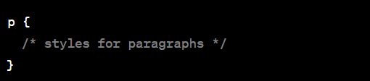  
  
**Class Selector:**

* Selects elements with a specific class attribute. Class selectors are preceded by a dot (**.**) and are written as **.classname**. For example, **.highlight** selects all elements with **class="highlight"**.

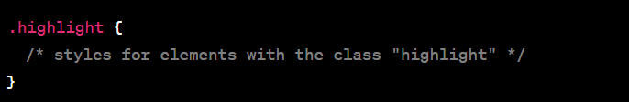  
  
**ID Selector:**

* Selects a single element with a specific ID attribute. ID selectors are preceded by a hash (**#**) and are written as **#idname**. For example, **#header** selects the element with **id="header"**.

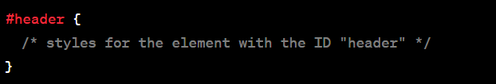  
  
**Attribute Selector:**

* Selects elements based on their attributes. Attribute selectors are written in square brackets. For example, **[type="text"]** selects all elements with **type="text"**.

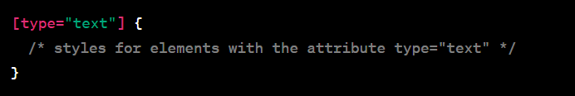  
  
**Combination of Selectors:**

* Selectors can be combined to target more specific elements. For example, **h2.title** selects all **<h2>** elements with the class "title".

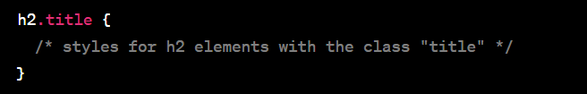  
  
**Descendant Selector:**

* Selects an element that is a descendant of another element. For example, **ul li** selects all **<li>** elements that are descendants of a **<ul>** element.

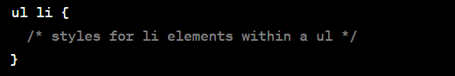

Q18:- What are the media types allowed by CSS?  
ANS:- CSS (Cascading Style Sheets) allows you to apply styles based on different media types, enabling you to create styles tailored for specific devices or environments. The **@media** rule is used to define different styles for different media types. Here are some common media types allowed by CSS:  
  
**all:**

* This is the default media type. Styles defined for **all** apply to all devices.

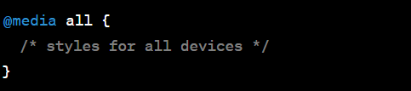  
  
**print:**

* Styles defined for the **print** media type apply when the document is printed.

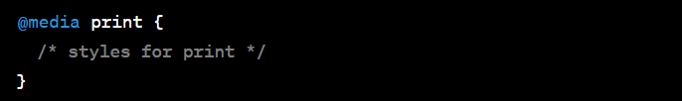  
  
**screen:**

* Styles defined for the **screen** media type apply to devices with screens, such as computer monitors.

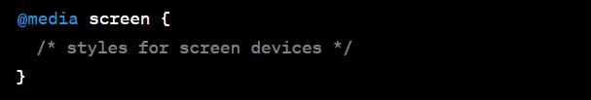  
  
**speech:**

* Styles defined for the **speech** media type apply to speech synthesizers or screen readers.

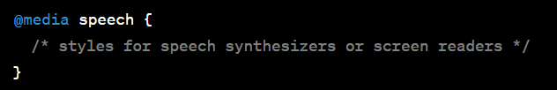  
  
**only:**

* The **only** keyword is used to hide styles from older browsers that do not support media queries.

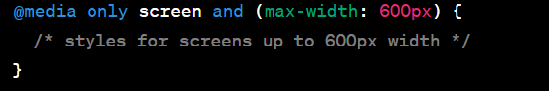  
  
**not:**

* The **not** keyword is used to apply styles if a certain condition is not true.

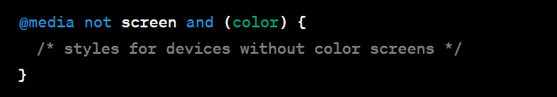  
  
**and:**

* The **and** keyword is used to combine multiple conditions within a media query.

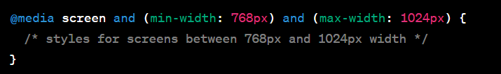

Q19:- What is the rule set?  
ANS:- In CSS (Cascading Style Sheets), a rule set consists of one or more style rules that define how a specific HTML element or group of elements should be styled. A rule set is composed of two main components: a selector and a declaration block.  
  
**Selector:**

* The selector is used to target HTML elements to which the styles will be applied. It can be an HTML tag, a class, an ID, or a combination of these. The selector defines the scope of the styling.

**Declaration Block:**

* The declaration block is enclosed within curly braces **{}** and contains one or more property-value pairs separated by semicolons. Each property-value pair defines a styling rule for the selected element(s).

